AI ASSISTANT CODING
2303A51994
ASSIGNMENT 9.1
QUESTION 1
PROMPT:
Write documentation in:
- Docstring format
- Inline comments
- Google-style documentation
Also compare the three approaches and recommend the best style for a mathematical utilities library.
CODE:
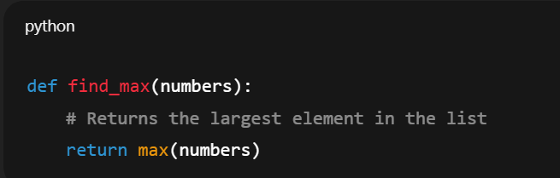
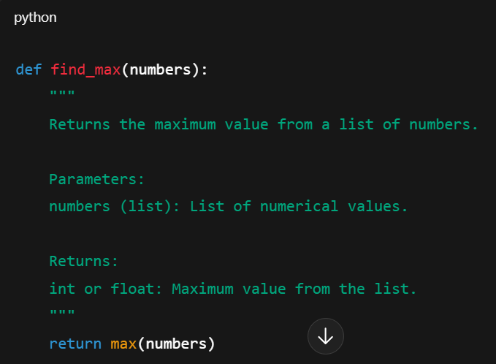
INLINE COMMENTS:

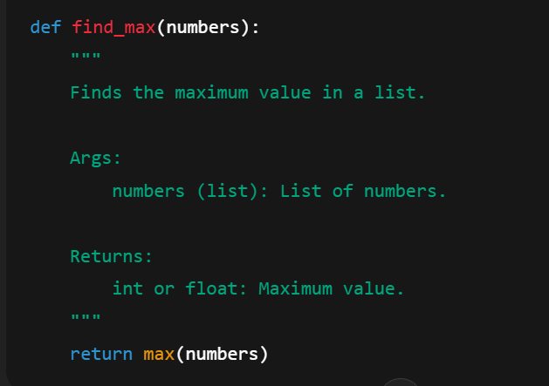
GOOGLE STYLE DOCUMENTATION:

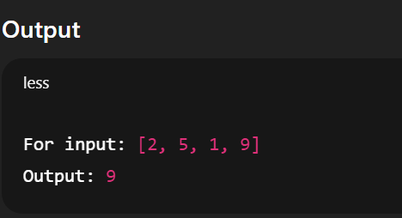

QUESTION 2:
PROMPT:
Write documentation in three formats and recommend the best style for new developers.
CODE:
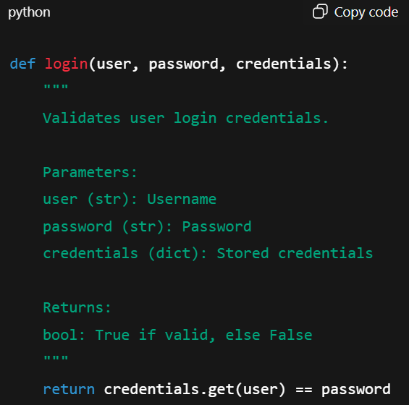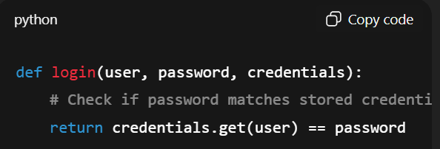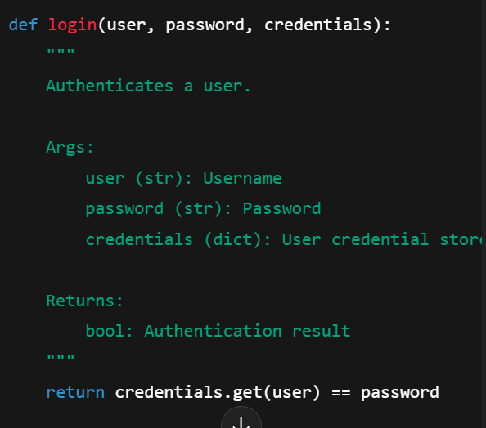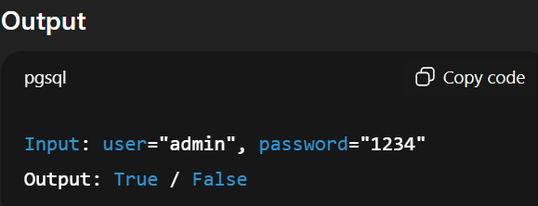
EXPLANATION:
Google-style documentation is most helpful for new developers as it clearly explains parameters and return values in a structured manner.

QUESTION 3:
PROMPT:
Design a Python module calculator.py and demonstrate automatic documentation generation.
CODE:
"""
Conversion Utilities Module
"""

def decimal_to_binary(n):
"""Converts decimal to binary."""
return bin(n)[2:]

def binary_to_decimal(b):
"""Converts binary to decimal."""
return int(b, 2)

def decimal_to_hexadecimal(n):
"""Converts decimal to hexadecimal."""
return hex(n)[2:]
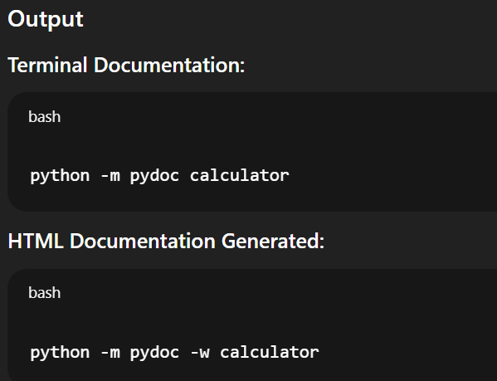

EXPLANATION:
Explanation
- Docstrings allow automatic documentation generation.
- pydoc extracts function and module details.
- HTML output provides readable documentation.

PROBLEN 4:
PROMPT:
Create conversion.py and generate documentation automatically.
CODE:
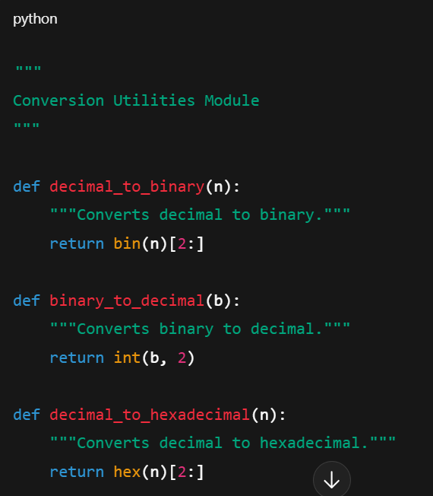

OUTPUT:
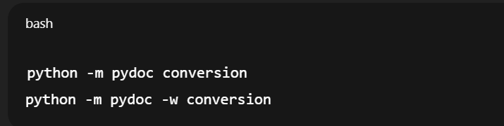
EXPLANATION:
Automatic documentation improves understanding of conversion utilities and supports reuse.

PROBLEM 5:
PROMPT:
Create course.py and generate documentation.
CODE:
"""
Course Management Module
"""

courses = {}

def add_course(course_id, name, credits):
"""Adds a course."""
courses[course_id] = {"name": name, "credits": credits}

def remove_course(course_id):
"""Removes a course."""
return courses.pop(course_id, None)

def get_course(course_id):
"""Gets course details."""
return courses.get(course_id)
OUTPUT:
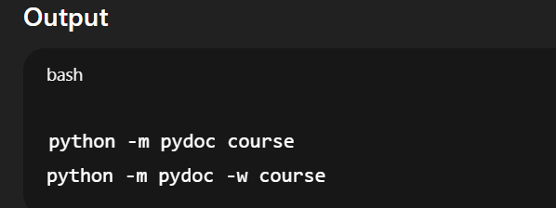
Explanation
Course functions are documented using docstrings which allow automatic documentation generation.

